Performance report
Acme-Antenna v1.0

Introduction

In order to evaluate the performance of the project, we split the functional requirements into use cases and developed one JMeter test per use case.

200 concurrent users were used in all tests, as when it was increased above that we got random “Connection closed by peer” type errors in JMeter, at a very low probability, which increased if we increased the number of concurrent users more. Since at 200 users the system was always stable with 0.00% errors, we decided that the system supports a maximum of 200 simultaneous users.

Use case 5.1: Register as user
In this use case the user creates an account for himself.
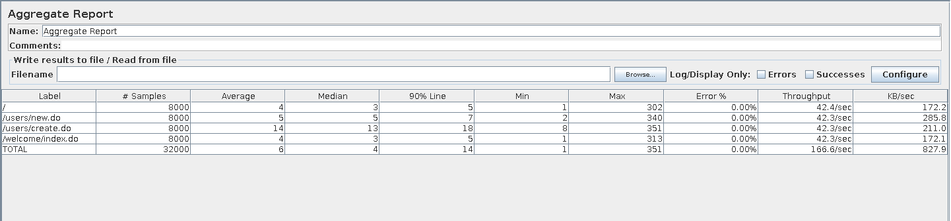
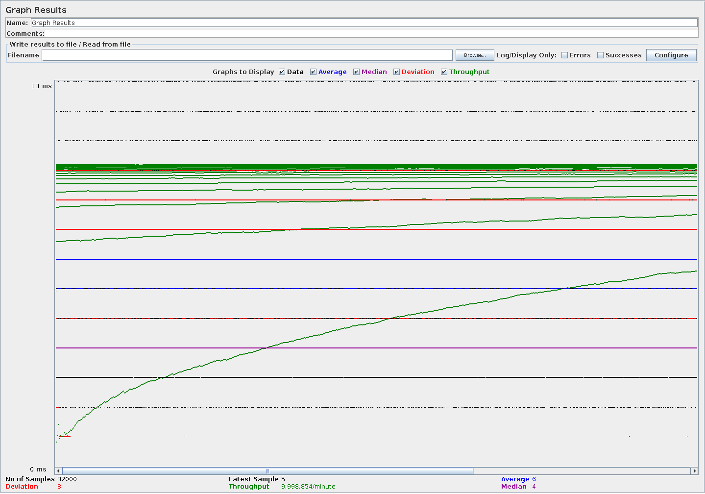

Use case 5.2: Satellite navigation
In this use case the user lists the available satellites, displays one, and navigates to an associated platform.
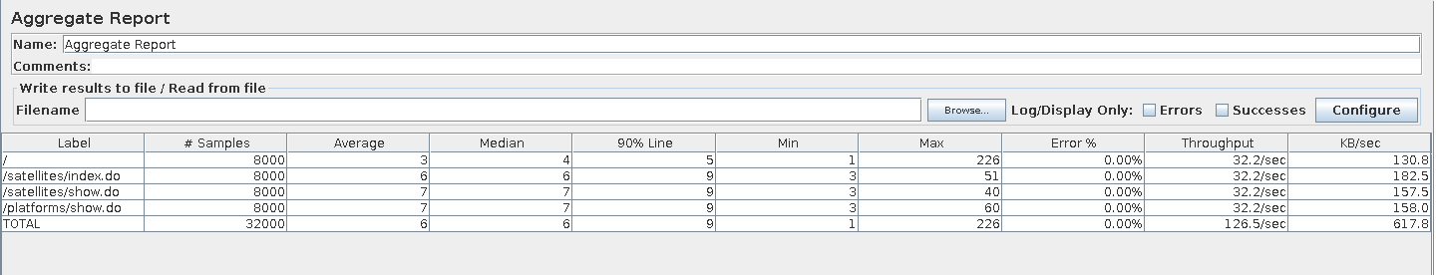
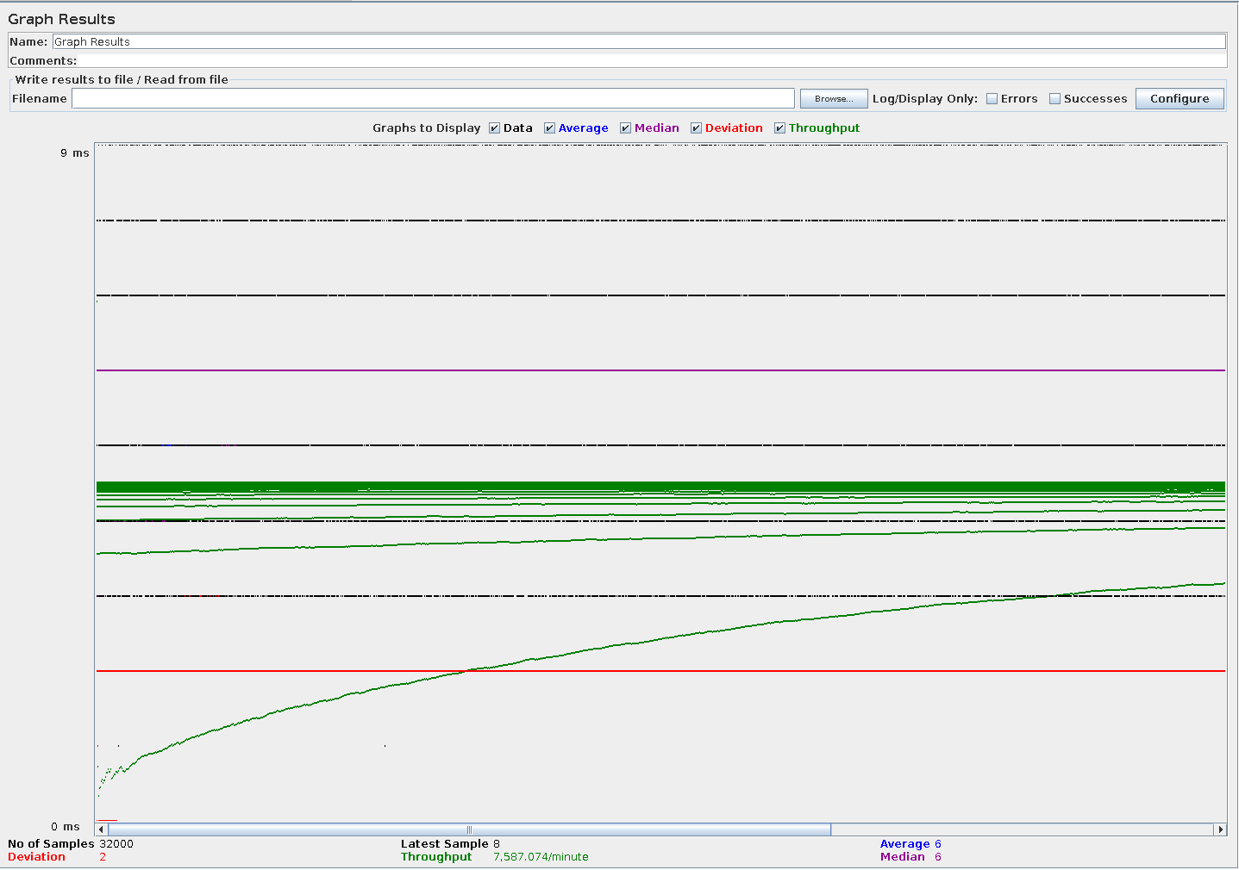

Use case 5.3: Platform navigation
In this use case a user lists the available platform, displays one, and navigates to an associated satellite.
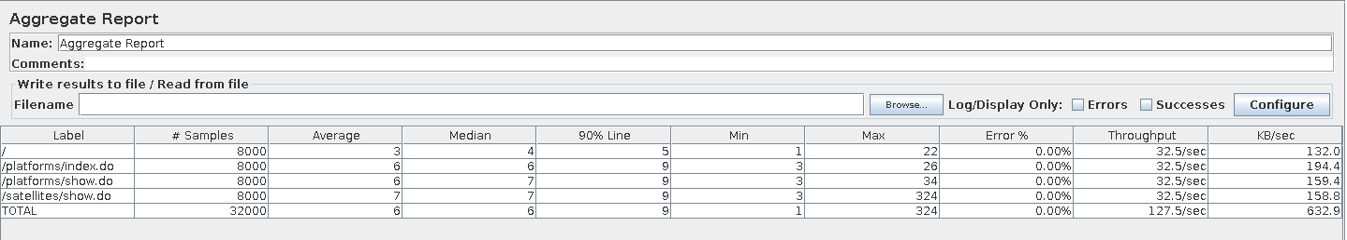
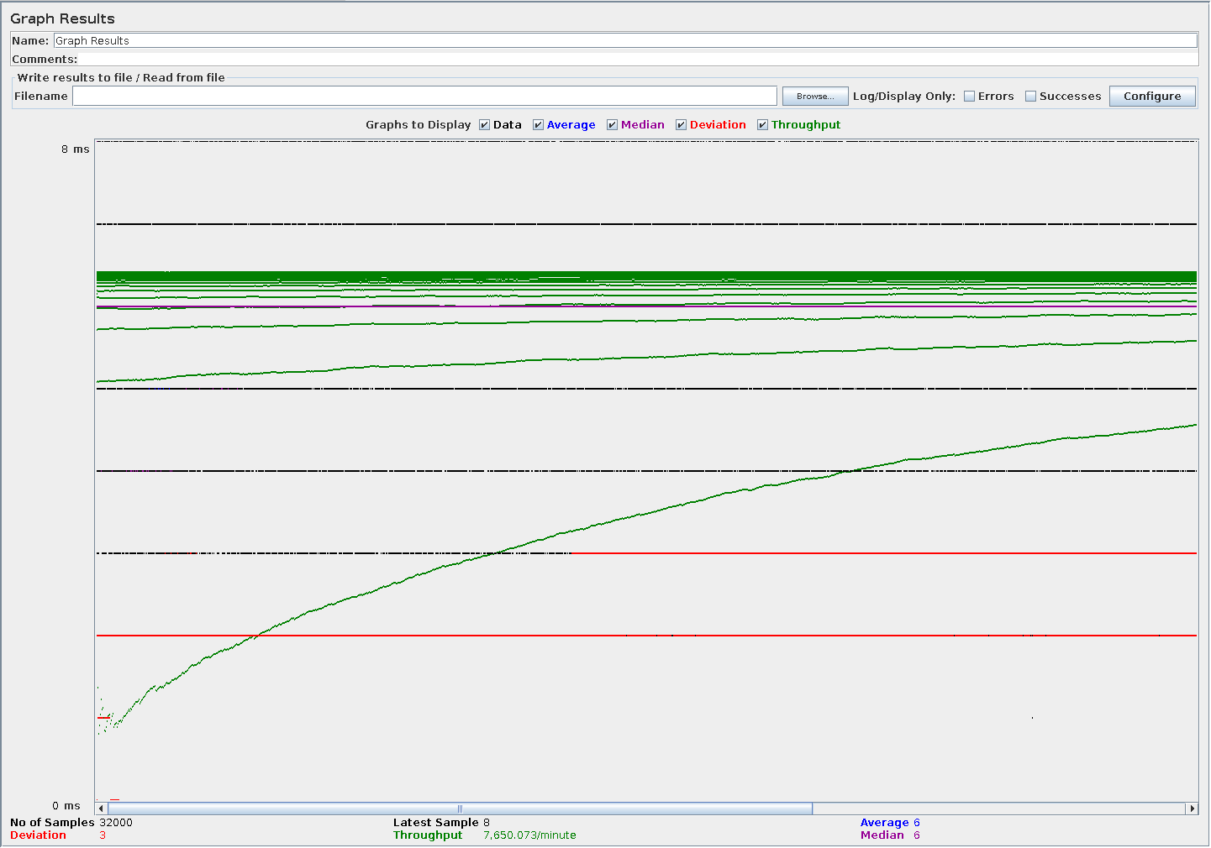

Use case 5.4: Search for keyword
In this use case an user searches by keyword over the available platforms, then over the available satellites.
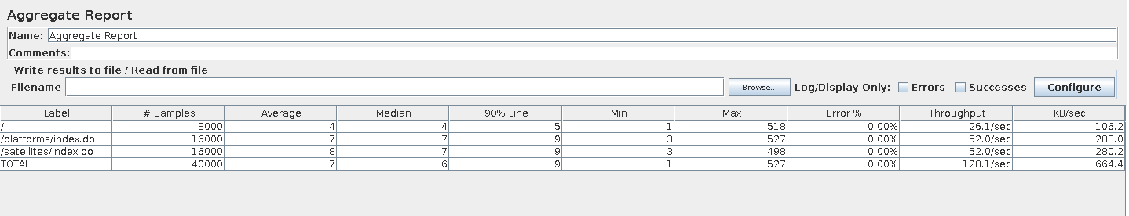
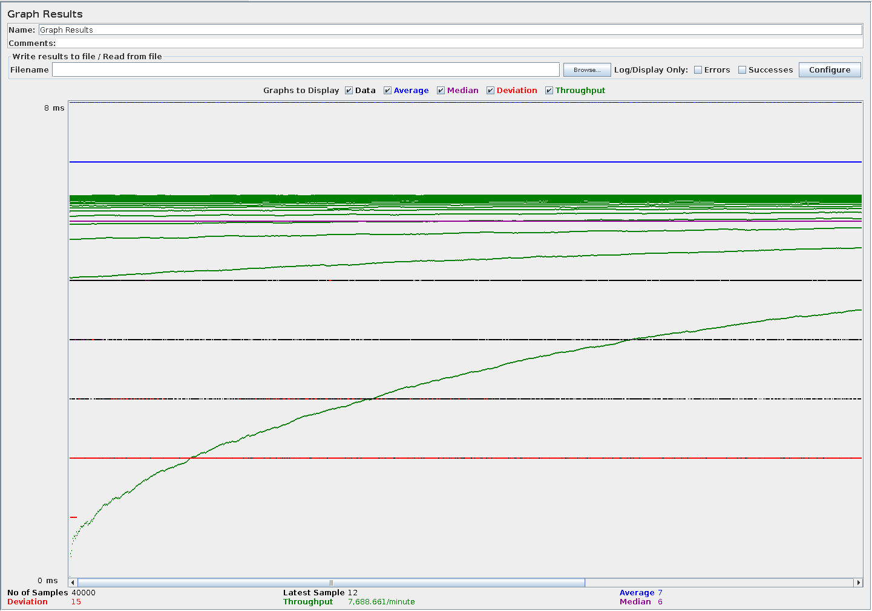

Use case 6.2: Antenna management
In this use case an user lists the available antennas, then displays, creates, updates and then deletes a new antenna.
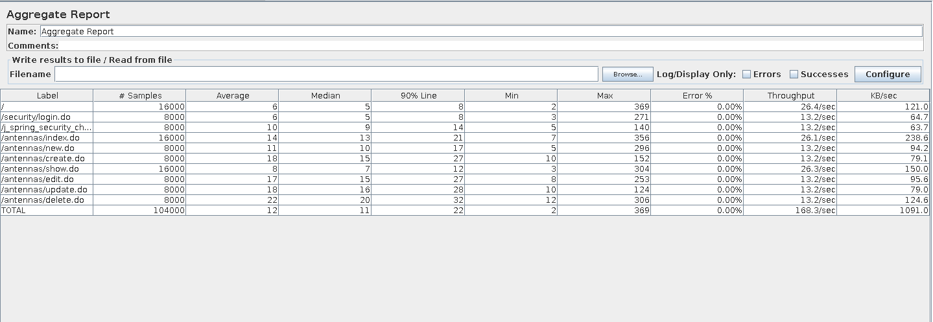
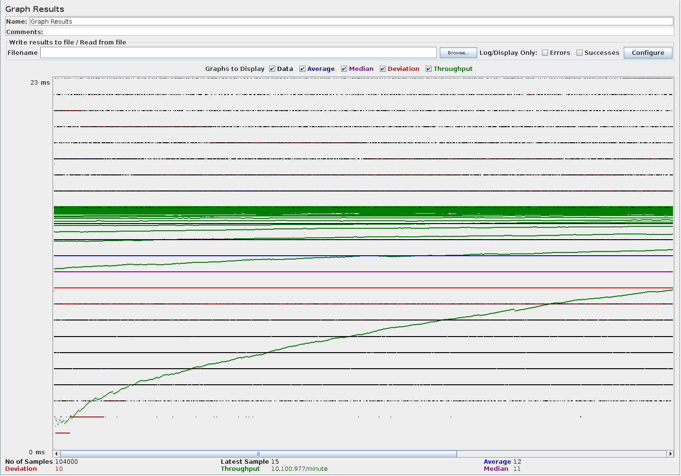

Use case 6.3: Platform subscription
In this use case an user subscribes to a platform using a credit card.
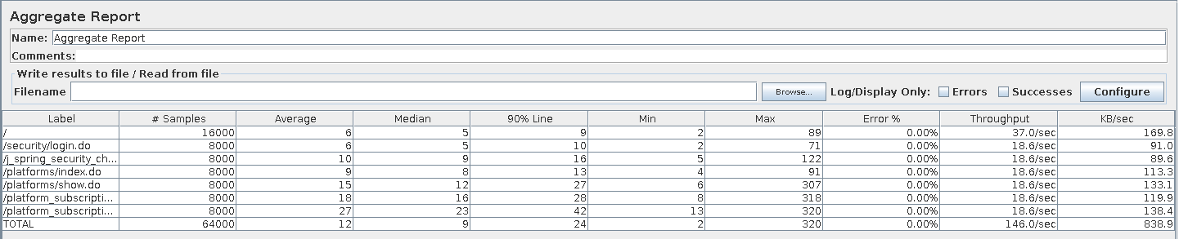
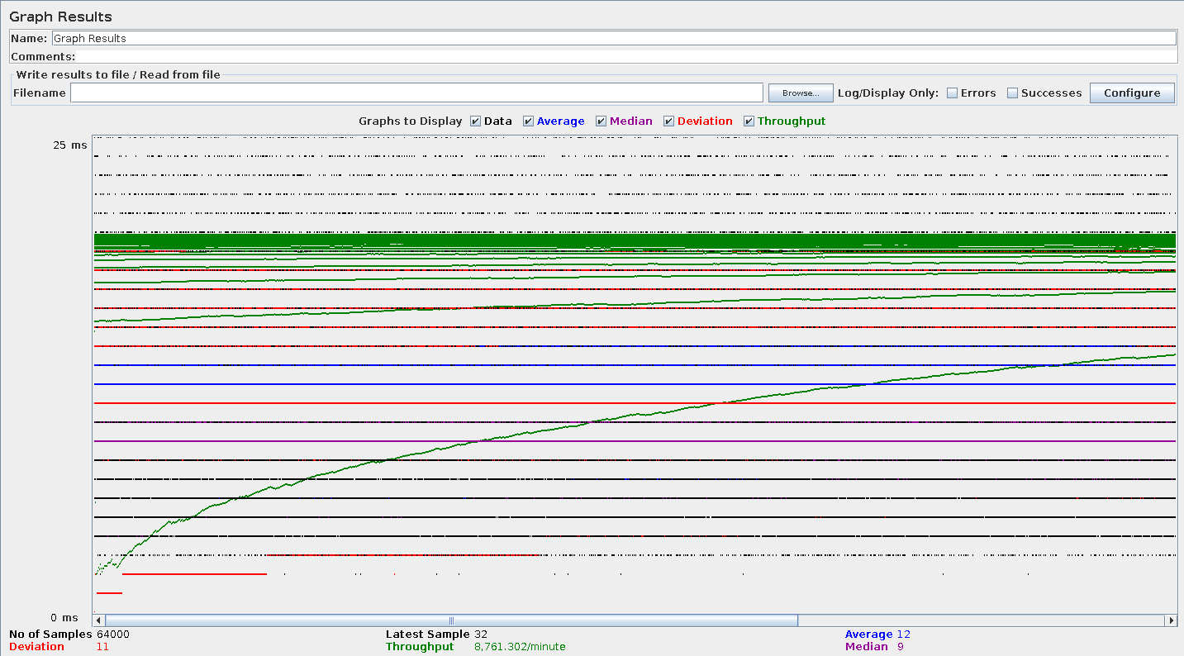

Use case 7.1: Display administrator dashboard
In this use case an user displays the administrator dashboard.

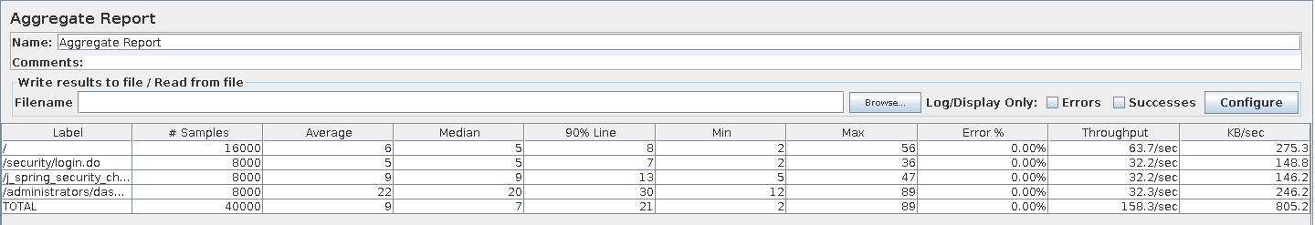
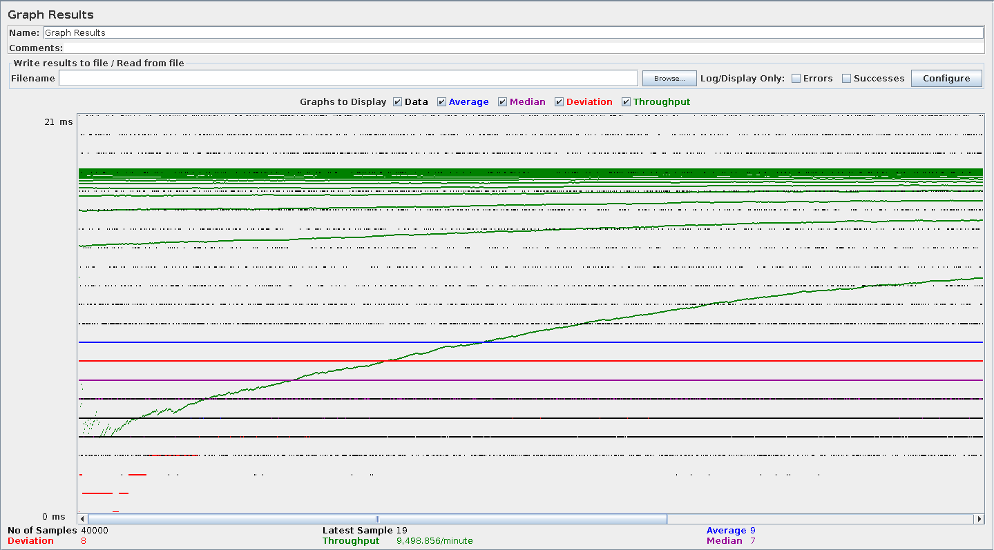

Use case 15.2: List and display tutorial
In this use case an user lists the available tutorials, then displays one.
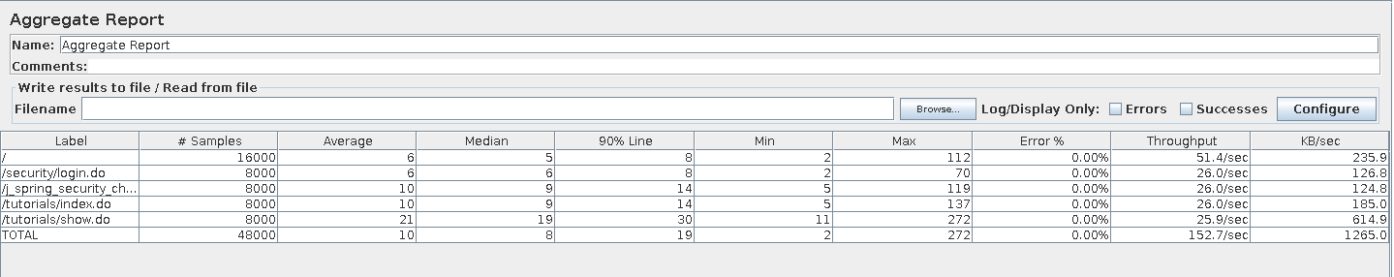
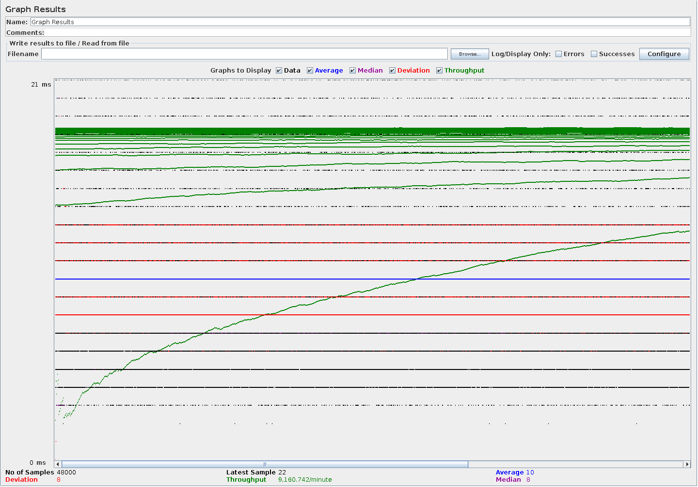

Use case 15.3: Tutorial management
In this use case an user creates, then updates a tutorial.
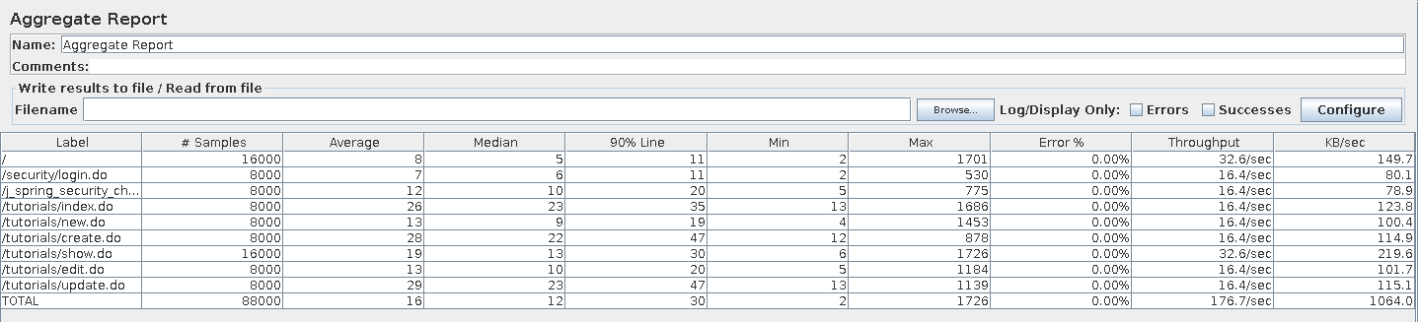
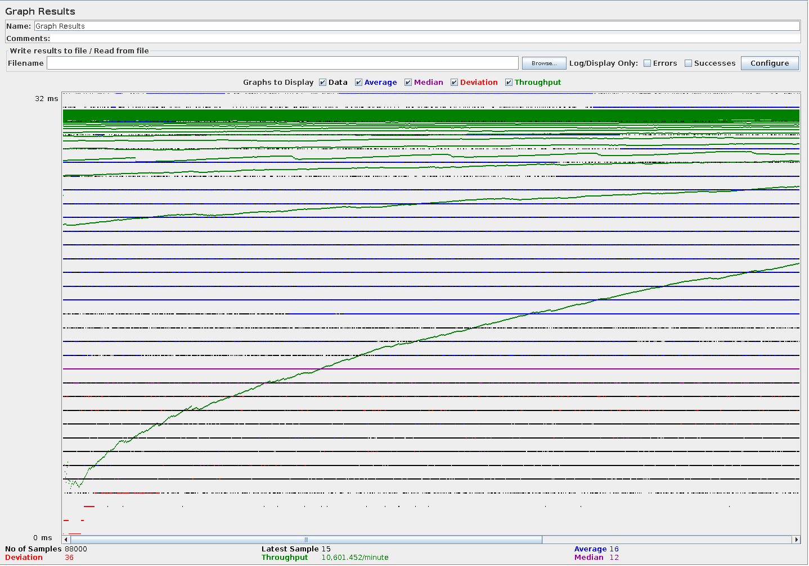

Use case 15.4: Commenting on tutorials.
In this use case an user writes a comment on a tutorial.
